**Lauren Pelayo, Alex Lundin, Thomas Lindholm**

PHYS 2125.104.603

Sep. 11, 2015

**Lab 2: Vectors**

**Table of Contents**

**1.) Cover Page**

**2.) Data**

**3.) Calculations**

**4.) Analysis Questions**

**-Plots**

**-Answers**

Lab 2: Vectors

TA: Matthew Fong

Lab Section: #603

September 11, 2015

Lauren Pelayo ()

Alex Lundin ()

Thomas Lindholm ()

2.) Data:



Table 2: Data table for air track measurements.



Table 3: Data table for force table measurements.

3.) Calculations:

Sample calculations from:

$A_{y}=$ $Asinθ$

$A_{x}=$ $Acosθ$

4.) Analysis:

**(Q6.0.3)**

1. The elevation and incline angle increase
2. Free body diagram
3. Free body diagram
4. Label FDB
5. Label FDB
6. X and Y components of weight on glider

4.) Analysis:

**(Q6.0.4)**

1. Free Body Diagrams
2. X & Y Axes Labels
3. X & Y vector forces components

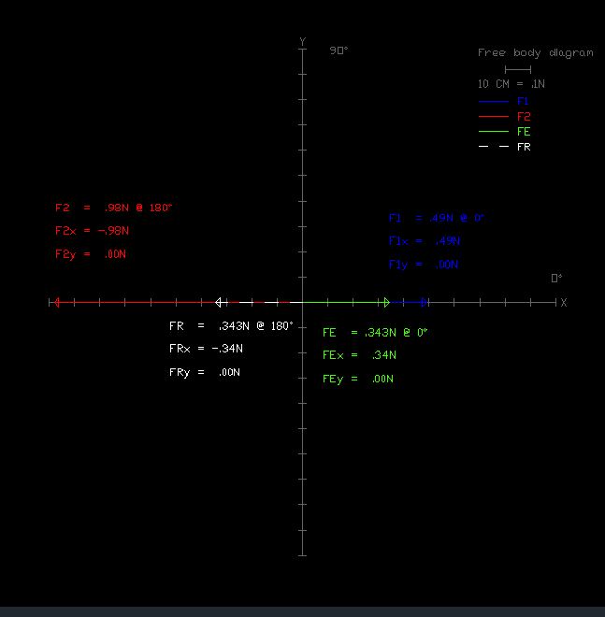

Free Body Diagram 1: Trial 1.

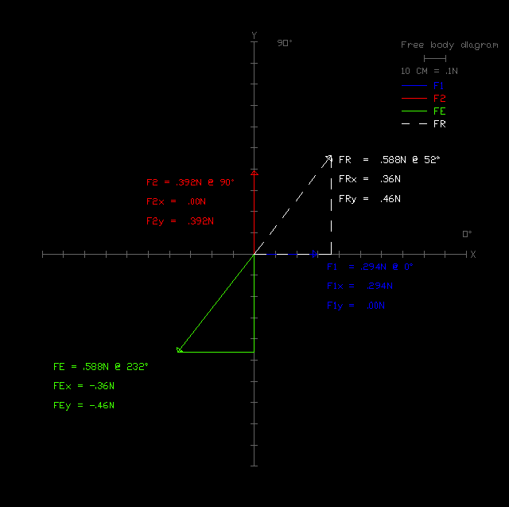

Free Body Diagram 2: Trial 2.

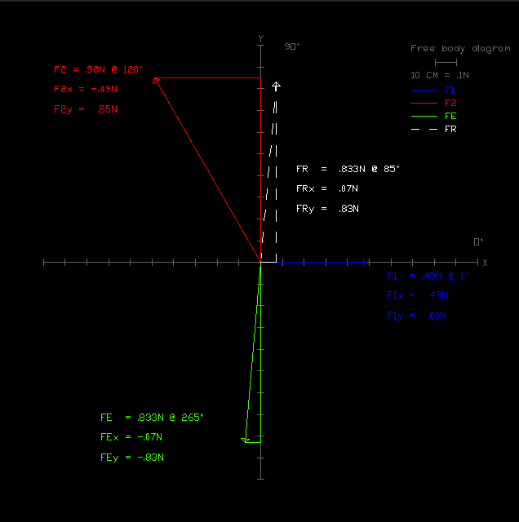

Free Body Diagram 3: Trial 3.

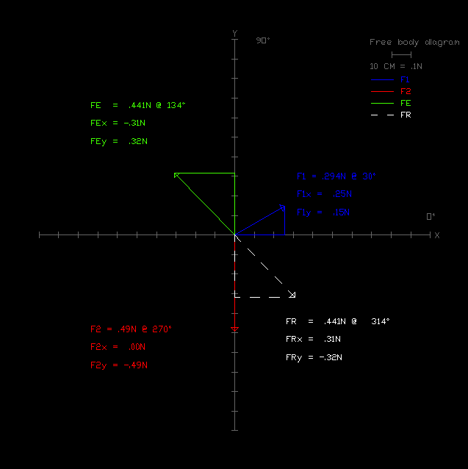

Free Body Diagram 4: Trial 4.

4.) Analysis:

**(Q6.0.4)**

1. Graphical Solutions

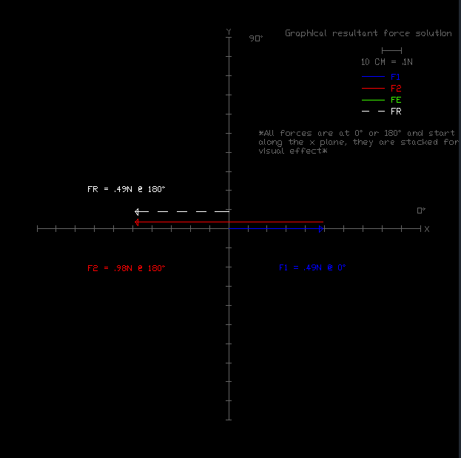

Graphical Solution 1: Trial 1.

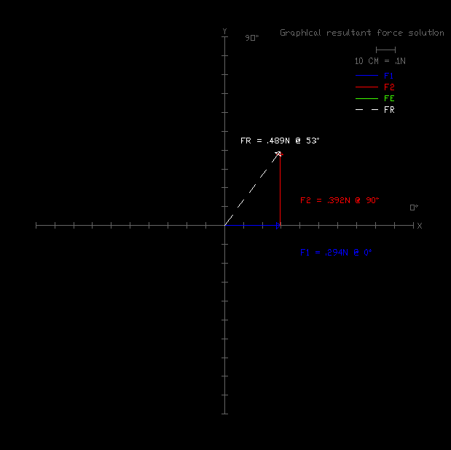

Graphical Solution 2: Trial 2.

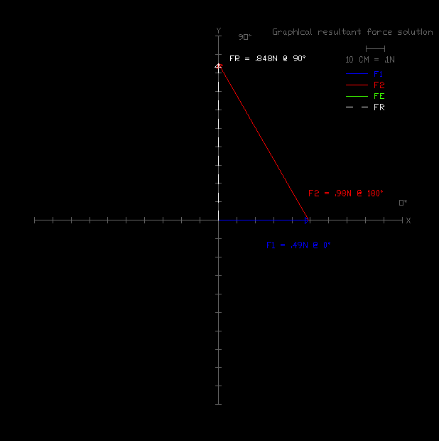

Graphical Solution 3: Trial 3.

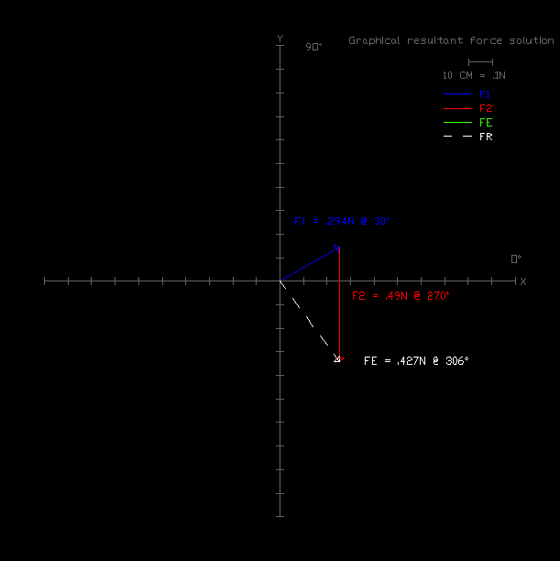

Graphical Solution 4: Trial 4.

1. Component addition



Table 3: Component Addition.